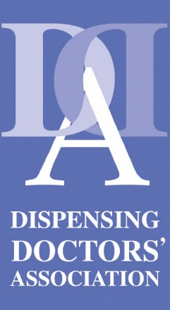
Press release: The DDA urges the BMA to bring dispensing GPs to the negotiating table
The Dispensing Doctors’ Association will use the platform of its 2023 annual conference to urge the BMA to review its ‘Call to Action for General Practice’ to highlight the ongoing challenges in dispensing practice.
Launching a complementary Call to Action for Dispensing Practice, DDA Chairman Dr Richard West will urge dispensing GPs to contact their LMCs to pressure the BMA to include an expert dispensing practice representative in all negotiations on behalf of dispensing GP BMA members.
The DDA believes that current BMA negotiations are failing over 3,000 dispensing GPs, who work in more than 1,100 practices across the UK, and who serve around 9.9 million rural patients. The dispensing service provided by this body of GPs is specifically designed to supply vital NHS medicines to patients who live remotely from a community pharmacy.
The DDA supports the principle aim of the BMA’s ‘Call to Action’ to establish a fit-for-purpose and modern core GP contract. However, many elements of dispensing GP funding now require the urgent attention of the BMA, specifically:
- The dispensing practice discount abatement mechanism (‘clawback’) is now 25 years old and it no longer reflects current discount rates: hundreds of branded medicines and appliances are supplied with no discount available, financially penalising every practice, every time that they dispense these items.
- The dispensing fees envelope has not been updated in line with DDRB annual inflationary GP staff pay uplifts since 2019. This has devalued the fee by 20 per cent, putting immense pressure on dispensing practice operating costs and jeopardising safe staffing levels.
The DDA also believes that a fit-for-purpose dispensing GP contact will also recognise the imperative to deliver evidence-based medicines optimisation services through dispensing practices. Examples of such services include the new medicines or discharge medicines services in dispensing practices.
The DDA is offering to support the BMA across the UK and regionally
to establish a dispensing doctor lead in policy negotiations.

Together, we can create national and regional GP policy
that always considers the unique needs of dispensing GPs
- for the benefit of the patient, the NHS and the practice.

For more information:
DDA Communications Officer: Ailsa Colquhoun
E: Ailsa.colquhoun@dispensingdoctor.org
Tel: 01892 519504

Notes for editors:
The DDA Conference takes place on September 27-28, 2023 at the Macdonald Burlington Hotel, Birmingham.

