Surgery name
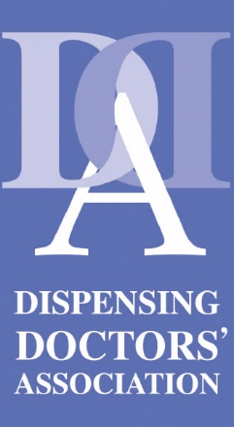
Address
Dear [insert politician name]
I am writing to you as a constituent and a GP serving [insert patient list size] patients in your constituency to ask you to raise your voice on behalf of constituents who are regularly failed by health policy.

We believe there are three key shortfalls in current rural health service policy, which affect patients’ ability to access the highest quality NHS services:

… for patients:
Pharmacies can offer a range of proven medicines services that promote safety and cost-efficiencies for the NHS – but these are currently unavailable to patients living in rural areas who receive NHS medicines from a dispensing GP.
Key take-away: The rights of dispensing patients must always be respected equally when considering pharmaceutical service policy in rural areas.

… for the NHS:
Developments such as the Electronic Prescription Service secure significant operational efficiencies throughout the NHS and for patients. However, around 1,200 dispensing practices, including ours, are unable to secure full NHS funding to implement this vital technology in our practice.
Key take-away: Dispensing practice policy and funding should encourage and protect innovation in dispensing practice.
… for the dispensing doctor practice:
- Profit margin control measures in dispensing practice (known as the NHS ‘clawback’) are now 25 years old; they no longer reflect the current drug marketplace and expose dispensing practices such as ours to financial penalties on hundreds of items, affecting us every time we dispense these items.

- Dispensing service fees have not been updated in line with inflation since 2019. Effectively, this has devalued fees by 20 per cent, putting immense pressure on our operating costs and forcing cut-backs. This puts patient safety at risk and reduces local employment opportunities.

Key take-away: Dispensing practices should never be expected to operate and dispense at a loss.

Together, we can create national and regional GP policy
that always considers the unique needs of dispensing patients
- for the benefit of the patient, the NHS and the practice.

Yours sincerely

GP partner name
Our surgery is proud to be a member of the Dispensing Doctors’ Association,
which exists solely to support excellence in dispensing practice

